**SAP Hybris**

SAP Hybris is a family of product from a German company Hybris, which sells e-Commerce, Marketing, Sales, Service and Product Content Management Software.

SAP Hybris provides solutions that helps any organization to cut cost, save time, reduce complexity and require lesser focus to achieve excellent customer experience.

Hybris Product focuses on the following main areas −

* Commerce
* Marketing
* Revenue (Billing)
* Sales
* Service
* Hybris as a Service (YaaS)

Commerce: It includes products for B2C Commerce, B2B Commerce, Product Content and Catalog Management, Omni-Channel fulfilment, and Merchandising to understand what customer wants and to turn visitors into buyers.

## SAP Hybris Commerce Accelerator

SAP Hybris Commerce Accelerator provides us ready-to-use Omni-channel commerce solutions with storefront templates and business tools that allows us to create an exceptional customer experience.

**SAP Hybris Accelerator** is designed to provide the platform and architecture of SAP Hybris Commerce that helps in reducing cost of ownership and speeds up the implementation process.

The SAP Hybris Commerce Accelerator is available for B2B, B2C, Financial services and other marketing types.

Following are the key advantages of using a SAP Hybris Accelerator concept −

* By using an Accelerator, we get an integrated, truly Omni-channel solution from the starting day of project implementation.
* By using an Accelerator, we can have a solid infrastructure to scale out the business requirement.
* It reduces the implementation cost and time by providing platform for different device types.
* Ease to use tools for building and maintaining a feature-rich shopping experience.

The following illustration shows the layered architecture of a SAP Hybris Commerce Accelerator.

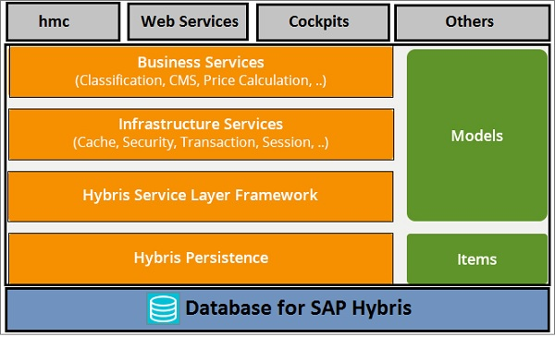

* The top layer includes – HMC, Web Services and Cockpits, which define objects that end user uses to interact with applications. Various user actions can be performed like adding a product to the cart, edit quantity in shopping carts and manage user profiles.
* Hybris Service Layer Framework is responsible to implement Java Application Programmer’s Interface for objects in the Hybris Commerce Suite.
* The Type layer defines business object models, which are generated based on types.
* The Persistence Layer is responsible for abstraction from database, caching and clustering.
* The Database layer is used to store the data contained in a Hybris Commerce suite.

Other important components include −

### **Cockpits**

This is one of the key component in the top layer in Hybris. Products are maintained in the product cockpit if there is a requirement to update the description, then it can be done using the product cockpit without making a change to the code. It also has the CMS cockpit that allows marketing content to be updated without any dependence on the IT team.

### **HMC or BackOffice**

HMC or Backoffice provides a single user interface to manage any kind of data. It can be used to access stores, sites, products, users, companies, and catalogs.

The following screenshots displays the Hybris B2C Accelerator that contains storefront templates and business tools based on best practices, which are designed to speed up the implementation and to reduce cost and implementation time.

# **Platform**

Hybris Platform consists of a standard set of extensions providing the main functionality of a Hybris installation. An extension is a group of features comprising a subset of SAP Hybris Commerce functionality. An extension can contain business logic, type definitions, a web application, and many other things.

# **Architecture of SAP Hybris Commerce**

The architecture of SAP Hybris Commerce is flexible and modular. At the foundation level of architecture is Hybris Platform consisting of core functionality upon which all other functionality is built.

**Basic Architecture**

From a business point of view, SAP Hybris Commerce is divided into individual packages, such as Commerce, Content, Channel, and Orders. These packages are bundles of features assembled for a certain range of business functionality. All these packages rely on more basic functionality provided by the Hybris Platform. While the Hybris Platform can run without any package, no package can run without the Hybris Platform.

Packages consist of individual modules, also referred to as **extensions**.

Extensions written by Hybris provide standardized functionality and are supported and maintained by Hybris.

Extensions that are part of Hybris Platform proper are also referred to as the core extensions. On top of these core extensions, Platform contains several pieces of Hybris software, such as the build framework, and third-party software, such as the pre-bundled Apache Tomcat.

## Layer Architecture

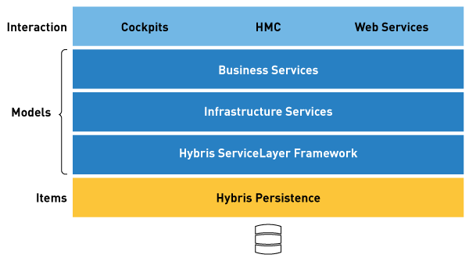

**Cockpits, HMC, Webservices:** This is where objects are represented in a way that an end-user can interact with them: add products to a cart, edit a product description, or set a password for a user account, for example.

Functionality on this level uses the ServiceLayer for functionality and the Type Layer for storage of objects.

**ServiceLayer Framework:** (including the actual ServiceLayer, the Infrastructure Services, and the Business Services)

The Hybris ServiceLayer relies on so-called models, which are POJO objects. Attributes on models have automatically generated getter and setter methods.

* It provides a clean separation of business logic and persistence logic.
* It provides a **framework** to develop your own services and to extend existing ones.
* It is heavily based on the **Spring** Framework.
* It is the layer where partners should implement their business logic.
* It provides hooks into model life-cycle events for performing custom logic.

SAP Hybris Commerce exposes all its functionality through services. The following kinds of services are available:

* **Business Services** implement business use cases, such as cart handling or back order.
* **Infrastructure Services** provide the underlying technical foundation, such as internationalization, import, export, and so on.
* **System services** provide functionality required by the ServiceLayer, such as model handling and session handling.

[**Type Layer**](https://help.hybris.com/6.0.0/hcd/8c755da8866910149c27ec908fc577ef.html)**:** Describes business object models. It is on this layer that definitions of business objects (types) and their fields (attributes) are made via the items.xml (see [items.xml](https://help.hybris.com/6.0.0/hcd/8bffa9cc86691014bb70ac2d012708bc.html)) file. Models are generated based on types.

**Persistence Layer:** Deals with abstraction from the database, caching, and clustering. You are not likely to get into contact with the Persistence Layer at all as it is completely transparent and does not require any explicit interaction from your side.

**Database:** Although not a layer of SAP Hybris Commerce, the database is also an important component in this overview: the database makes the data held in SAP Hybris Commerce persistent.

## Modes of Operation

**Single Node:** The most basic mode of operation. A single machine running one instance of an SAP Hybris Commerce installation. Does not have several nodes (unlike in Cluster Mode) and only has one set of data (unlike Multi-Tenant mode).

**Cluster Mode:** [The Hybris Cluster](https://help.hybris.com/6.0.0/hcd/8b7c5c75866910148c329ee71f3a681e.html) consists of several individual nodes. These nodes access a common database and communicate among each other via the TCP or UDP protocol. Summing up, this is a multi-node, cross-linked version of Single Node.

**Multi-Tenant Mode:** SAP Hybris Commerce in [Multi-Tenant Mode](https://help.hybris.com/6.0.0/hcd/8c14e7ae866910148e59ebf4a2685857.html) allows using several individual, distinguished sets of data separated by database table prefixes. Multi-Tenant Mode can be used for Single Node and for Cluster Mode operation.

**The Hybris Cluster** is number of individual, separate SAP Hybris Commerce instances sharing one single set of data, whereas the **multi-tenant SAP Hybris Commerce** is one single SAP Hybris Commerce using separate sets of data.